PRESS RELEASE

COMMUNICATIONS AND MEDIA TEAM OF THE 2023 ASEAN SUMMIT

No.79/SP/TKM-ASEAN2023/ENG/5/2023

IMT-GT Strengthens Connectivity and Tourism in Three Countries

West Manggarai, 11 May 2023 – The results of the 15th Indonesia-Malaysia-Thailand Growth Triangle (IMT-GT) Summit are believed to be able to increase connectivity and growth in the tourism sector for the three countries.
Minister of Tourism and Creative Economy/Head of the Tourism and Creative Economy Agency Sandiaga Salahuddin Uno said it at Batu Cermin Cave, Labuan Bajo, West Manggarai, East Nusa Tenggara, Thursday, 11 May.
At the same time, Indonesia launched IMT-GT Visit Year 2023-2025 as an ASEAN subregion that is expected to involve ten provinces in Sumatra, Southern Thailand, and Malaysia.
"One of the main issues is industry downstream including the tourism industry, as well as strengthening connectivity so that the target can further increase tourist visits," he said.
According to Sandiaga, the three countries are geographically and culturally close. "Hopefully, we can achieve the initial target of 60 million tourists with the IMT-GT Visit Year 2023-2025, so there is a potential for an additional US$75 billion in foreign exchange. Indonesia is chosen as leader in this visit year," said Sandiaga.
According Sandiaga, Tourism and Creative Economy Ministry would start by initiating this program in Bangka Belitung and South Sumatra.
"After that, we will come to ten Sumatra provinces, including events in Malaysia and Thailand. Also, connectivity between Batam-Bintan and Malaysia-Johor and several other destinations to increase the connectivity of the three countries," he said.
Finally, said Minister Sandiaga, his ministry will hold a world entrepreneur summit event in Padang, West Sumatra.
"Earlier, I immediately invited the Malaysian Prime Minister, representatives from the Thai government, and the Secretary General of ASEAN to attend the event as part of events designed for IMT-GT," he said.
The Malaysian and Thai delegations welcomed Indonesia's plan to encourage one of the pillars, which is halal tourism by Malaysia and Thailand.
"I also brought a gift for Labuan Bajo. Earlier, while accompanying the Singaporeean Prime Minister, we had a chance to talk about establishing a flight from Singapore to Labuan Bajo," said Minister Sandiaga.
Previously, Indonesia’s President Joko Widodo chaired the 15th Indonesia-Malaysia-Thailand Growth Triangle (IMT-GT) Summit on Thursday, 11 May, at Meruorah Hotel, Labuan Bajo, East Nusa Tenggara.
President Jokowi conveyed his joy because the IMT-GT volume managed to reach US$618 billion during the global situation in 2021.
He hoped that the IMT-GT would further encourage the acceleration of inclusive and sustainable economic growth to face the various challenges ahead.
Accompanying Minister Sandiaga were the Deputy for Resources and Institutions of the Ministry of Tourism and Creative Economy/Baparekraf, Martini Mohamad Paham; Secretary of the Ministry of Tourism and Creative Economy, Ni Wayan Giri Adnyani; Head of the Ministry of Preservation/Baparekraf Communication Bureau, I Gusti Ayu Dewi Hendriyani; and the President Director of BPOLBF, Shana Fatina. (Kemenparekraf/TR/Elvira/WS)

***

For more information, please contact:

Director General of Public Information and Communications of the Ministry of Communications and Informatics - Usman Kansong (0816785320)

Get other information at http://asean2023.id, https://infopublik.id/kategori/asean-2023, and https://indonesia.go.id/kategori/ragam-asean-2023

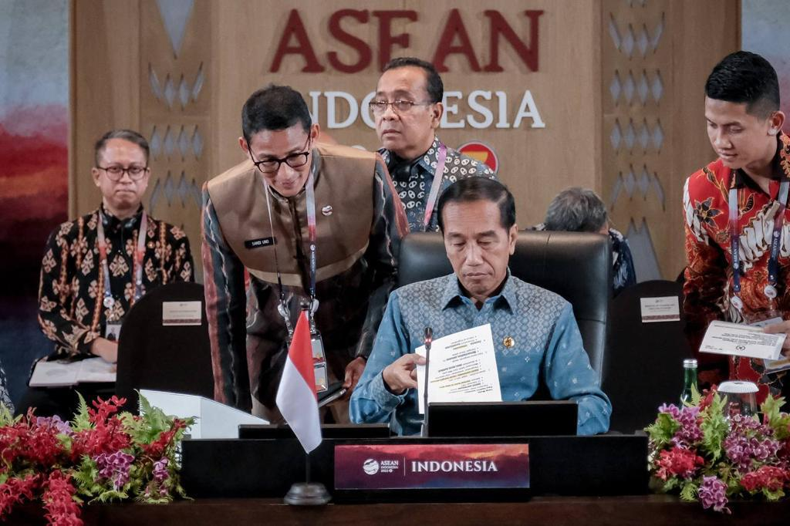
Indonesian President Joko Widodo chaired the 15th Indonesia-Malaysia-Thailand Growth Triangle (IMT-GT) Summit on Thursday, 11 May 2023, at the Meruorah Hotel, Labuan Bajo, East Nusa Tenggara. (Photo: Ministry of Tourism and Creative Economy)
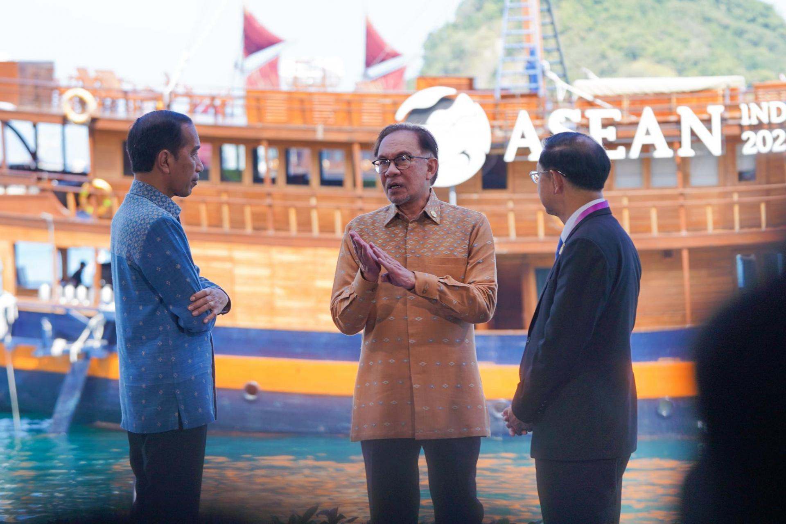
The ambiance of the 15th meeting of the IMT-GT (Indonesia-Malaysia-Thailand Growth Triangle) representative countries at the 42nd ASEAN Summit in Labuan Bajo on Thursday, 11 May 2023. (Photo: ASEAN2023 Host Photographer)

